R.VINOD REDDY, Advocate

Standing Counsel for TSTRANSCO/TSSPDCL

H.No.8-2-684/4/31, Plot No.26, Anand Banjara,

Road No.12, Banjara Hills, Hyderabad – 500034

Ph: 040-23304342
9849041514

Advance Receipt

Date : 05-06-2020

Received a sum of Rs. 10000/- (Rupees Ten Thousand only) from Superintending Engineer, Operation Circle, Rajendranagar TSSPDCL, towards filing Counter affidavit in WP. No 6370 of 2020 filed by M/s Sayyam Polymers before Honorable High Court.

- Legal Fee : Rs. 5000=00
- Filing Expenses : Rs 5000=00

Total : Rs. 10000=00

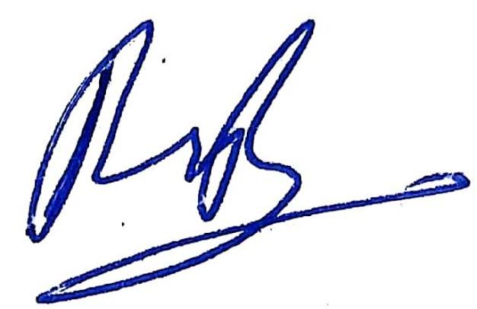
(R.Vinod Reddy)

